ELEC360 Control Theory & Systems I

Midterm Exam

Date: 20-October-2017

Time: 09:30 to 10:20 AM

Venue: ECS 125

Duration: 50 minutes

Instructions:

1. Please write your V number in the answer booklet.
2. Please verify if your question paper has 4 pages including this page.
3. Please use only non-programmable scientific calculators.
4. No formula sheet or aid sheet is allowed.
5. Please refrain from writing anything on the question paper.
6. Please return only the answer sheet at the end of the exam. You can carry the question paper with you.
7. Please be seated in your place (even after submitting your answer sheet) until an announcement is made to disperse.
8. Please answer all questions given in the three sections.
   1. Section A comprises of six questions each of 1 mark.
   2. Section B comprises of two questions each of 4 marks.
   3. Section C comprises of one question of 6 marks.
9. For Section A, please write only the question number and the option letter

1

Section A 6 x 1 = 6 marks

1. Unit step response of a first order system is shown in Figure 1. The transfer function of the system is in the form  +1, where *K* is the gain and *T* is the time constant of the system. Then the approximate value of time constant *T* is:

(1 mark)

(a) *T* = 1 second;

(b) *T* = 4 seconds;

(c) *T* = 18 seconds;

(d) *T* = 6 seconds;

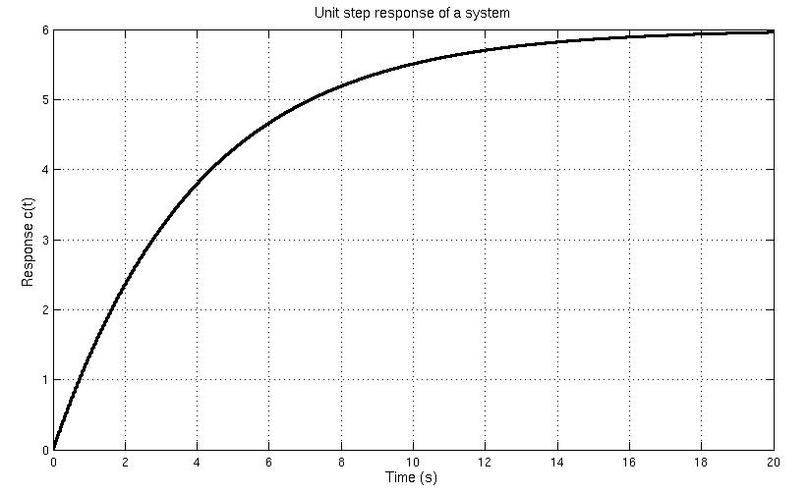

Figure 1. Unit step response of a system

1. Unit impulse response of a linear time invariant system for t ≥ 0 is given by the equation ( ) = 1 − / , where T is the time constant of the system. Then the unit step (unit step input is the integral of unit impulse input) response of the system is:

(1 mark)

1. 1 − − /
2. 1 − − /
3. − /
4. 1 − 1 − /

2

1. The characteristic polynomial of a closed loop system is found to be

5 + 2 4 + 3 2 + 4 + . Find the range of K for which the system is stable

(1 mark)

(a) K > 0

(b) 2 > K > 0

(c) 2 < K < 0

(d) None of the above

1. Unit step responses of a second order system for different damping ratio are given in Figure 2. If ζ1 and ζ2 correspond to damping ratio 1 and damping ratio 2 respectively, then which of the following is true?

(1 mark)

(a) ζ1 > 0; ζ2 >0; ζ2

> ζ1

(b) ζ1 > 0; ζ2 >0; ζ1 > ζ2

(c) ζ1 > 0; ζ2 >0; ζ2

= ζ1

(d) None of the above

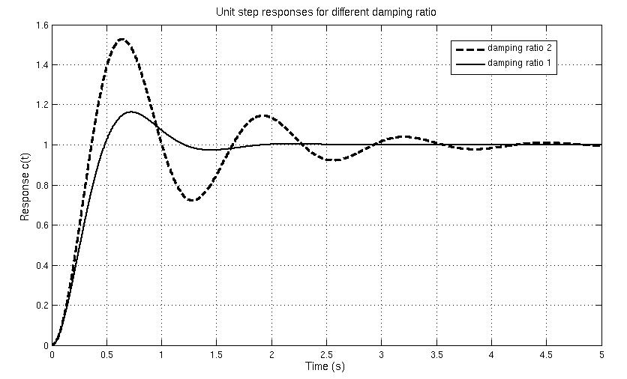

Figure 2. Unit step responses of a system for different damping ratio

5) Closed loop transfer function of a system is given by the equation

|  |  |  |  |  |
| --- | --- | --- | --- | --- |
| ( ) | | = | + 3 |  |
|  | |  |  |
| ( ) |  | ( + 1)( + 2) |  |

If it is known that the Laplace transform of impulse signal is unity and the Laplace

|  |  |  |  |  |  |
| --- | --- | --- | --- | --- | --- |
| transform of −  = | 1 | then the unit impulse response c(t) is given by: | | |  |
| + |  |
|  |  |  |  |  |
|  |  |  | (1 mark) |  |  |
| (a) −2  − 2 − |  | (b) −  − 2 −2 |  |  |  |
| (c) 2 −  − −2 |  | (d) 2 −2  − − | | |  |
|  |  | 3 | | |  |

1. Differential equation representation of a spring-mass-dashpot system is given below

22 + − + − = 0

Symbols *m*, *b*, *k* are system constants while *y* is the desired output and *u* is the input. Then the transfer function representation of the system assuming zero initial conditions is given by

(1 mark)

|  |  |  |  |  |  |  |
| --- | --- | --- | --- | --- | --- | --- |
| (a) |  | + | | (b) | 2+ + |  |
|  | 2+ + | | + |  |
| (c) | 2+ + | |  | (d) | + |  |
|  | + | | 2+ + |  |

|  |  |  |  |  |
| --- | --- | --- | --- | --- |
| Section B | | 2 x 4 = 8 marks | | |
|  |  |  |  | |
| 7) Reduce the block diagram to obtain the transfer function Y(s)/R(s) | |  | (4 marks) |  |

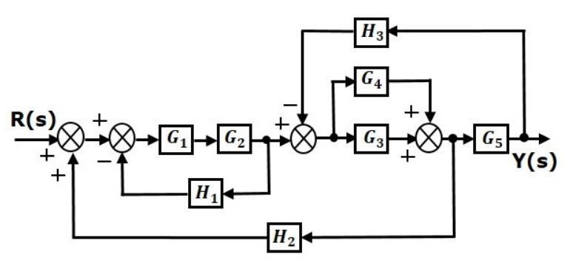

|  |  |  |  |  |  |  |  |  |
| --- | --- | --- | --- | --- | --- | --- | --- | --- |
| 8) Feedforward transfer function of a system is given as ( ) = | | ( +3.15) | | | | | |  |
|  |  |  | . Compute the | | |  |
| ( +1.5)( +0.5) | | |  |
|  |  | |  | | | |  |  |
| steady state error for unit ramp input assuming unity negative feedback. | | | | (4 marks) | |  |  |  |
| Section C | |  | 1 x 6 = 6 marks | | | | |  |
|  |  |  |  |  |  |  |  |  |

9) Plot the root locus of a system whose open-loop transfer function is given by the expression ( ) ( ) =  ( +0.5) . Also, mark the breakaway or break-in points, intersection

( +2)( +4)( +6)

point of asymptotes and angles of asymptotes. Further, from the root locus, comment on the range of *K* for which the closed loop system would be stable.

4